IP Preps

**C2. Camera Model**

**Intrinsic Parameters:**

* *focal length*: f – [mm] or [pixels]
* *pixel size*: (dpx, dpy) [mm]
* *principal point*: (u0, v0) - image center in pixel coordinates
* *distortion coefficients of lens*: radial (k1,k2), tangential (p1,p2)

**Extrinsic parameters:**

* *rotation vector*: r = [Rx, Ry, Rz]^T
* *translation vector*: T = [Tx, Ty, Tz]^T

**Camera frame => Image plane**

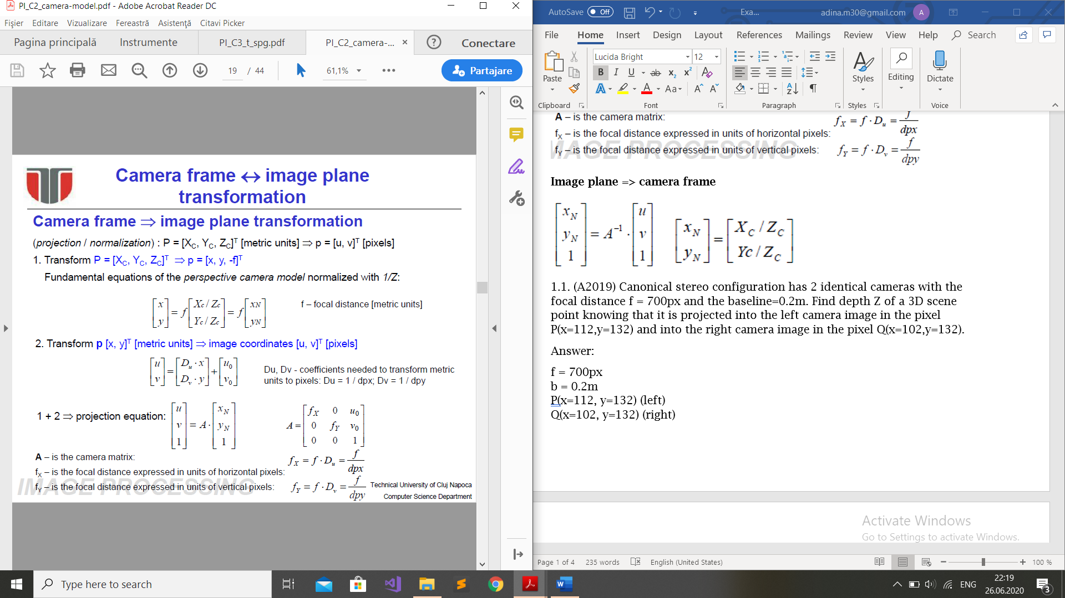

**Image plane => camera frame**

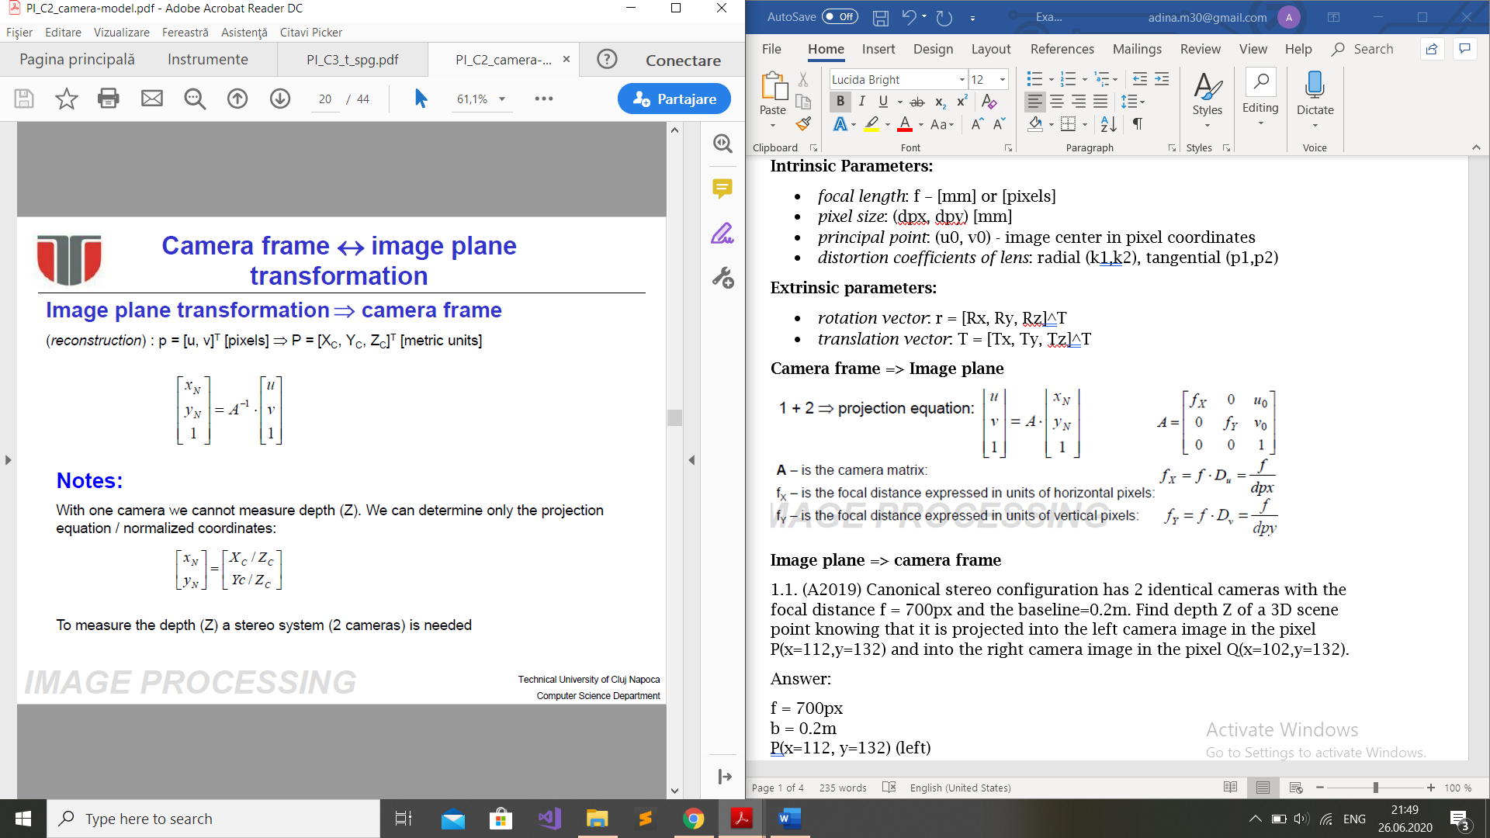 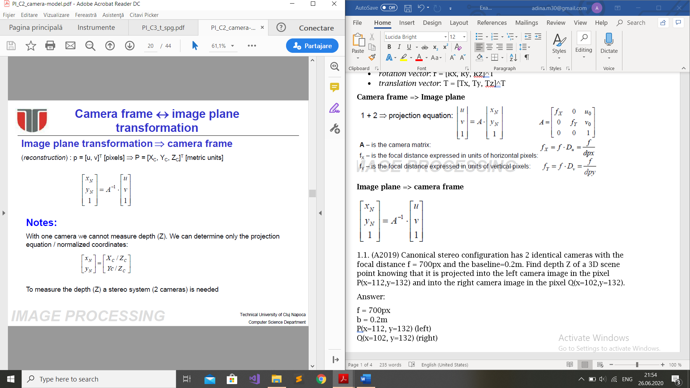

**World => Camera**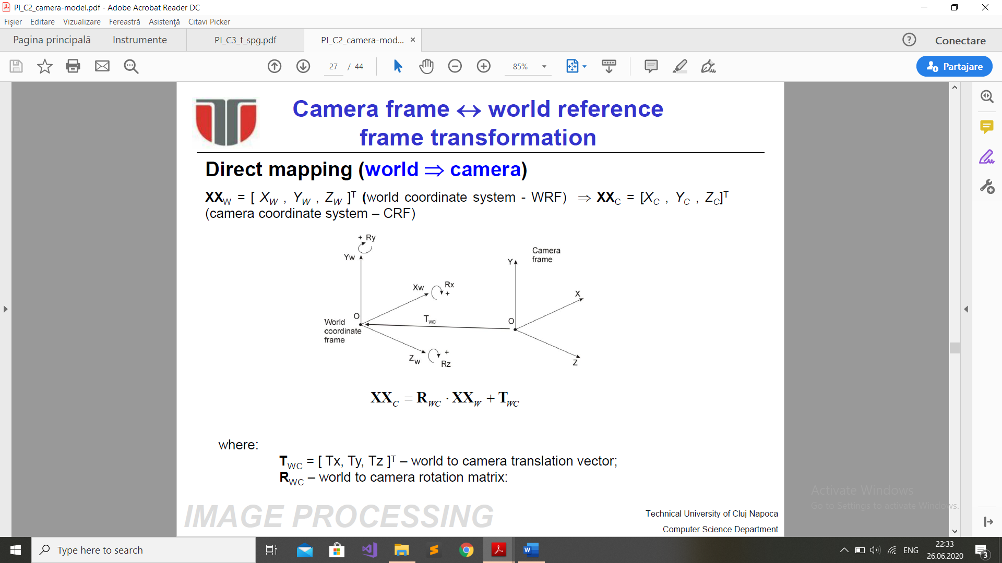

**Camera => World**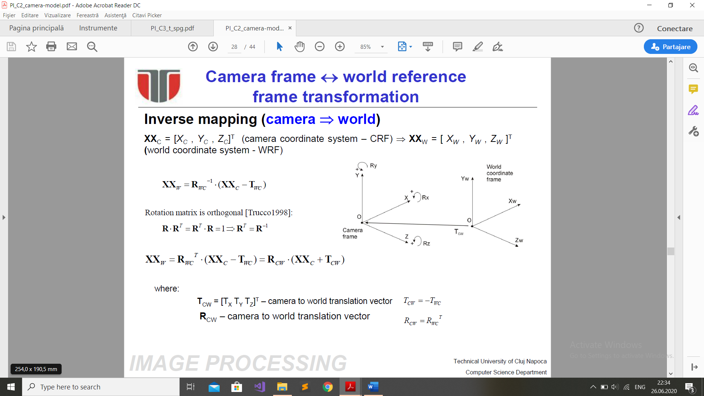

**3D world => 2D Image :** *Projection matrix*

**Distortion correction algorithm**

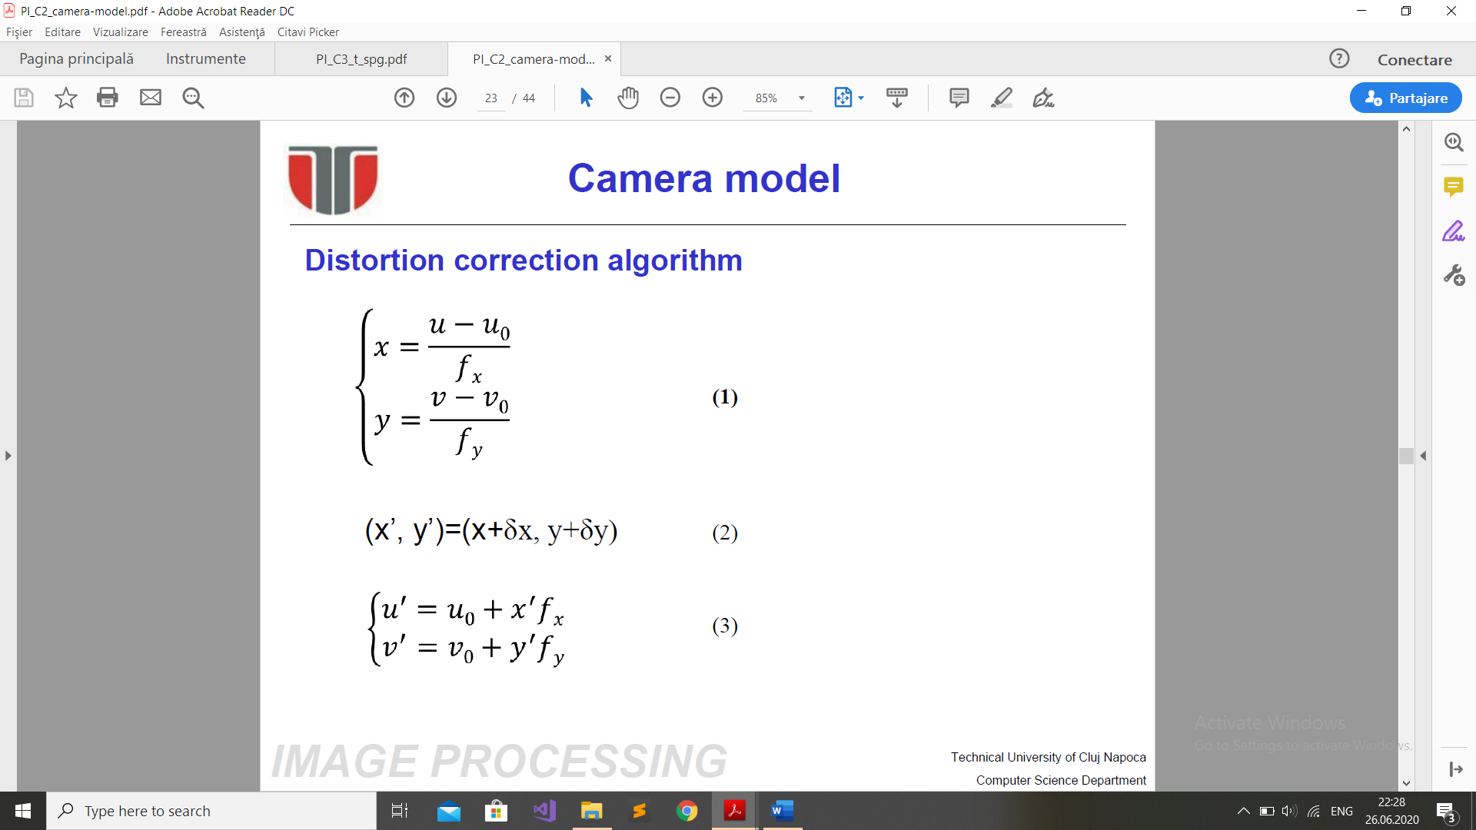

**C3. Thresholding**

**1. Using mean and standard deviation**

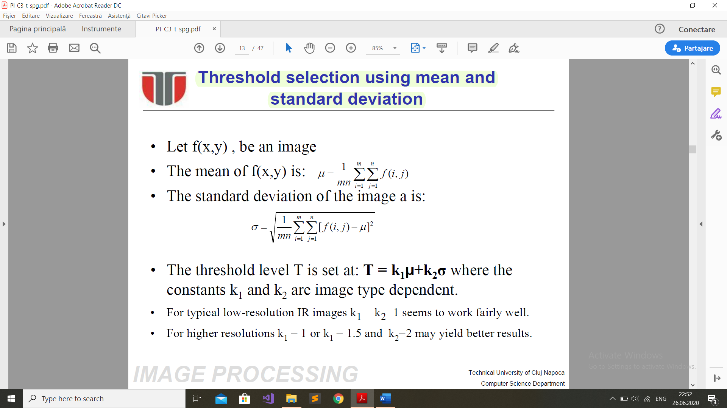

**2. By best approximation**

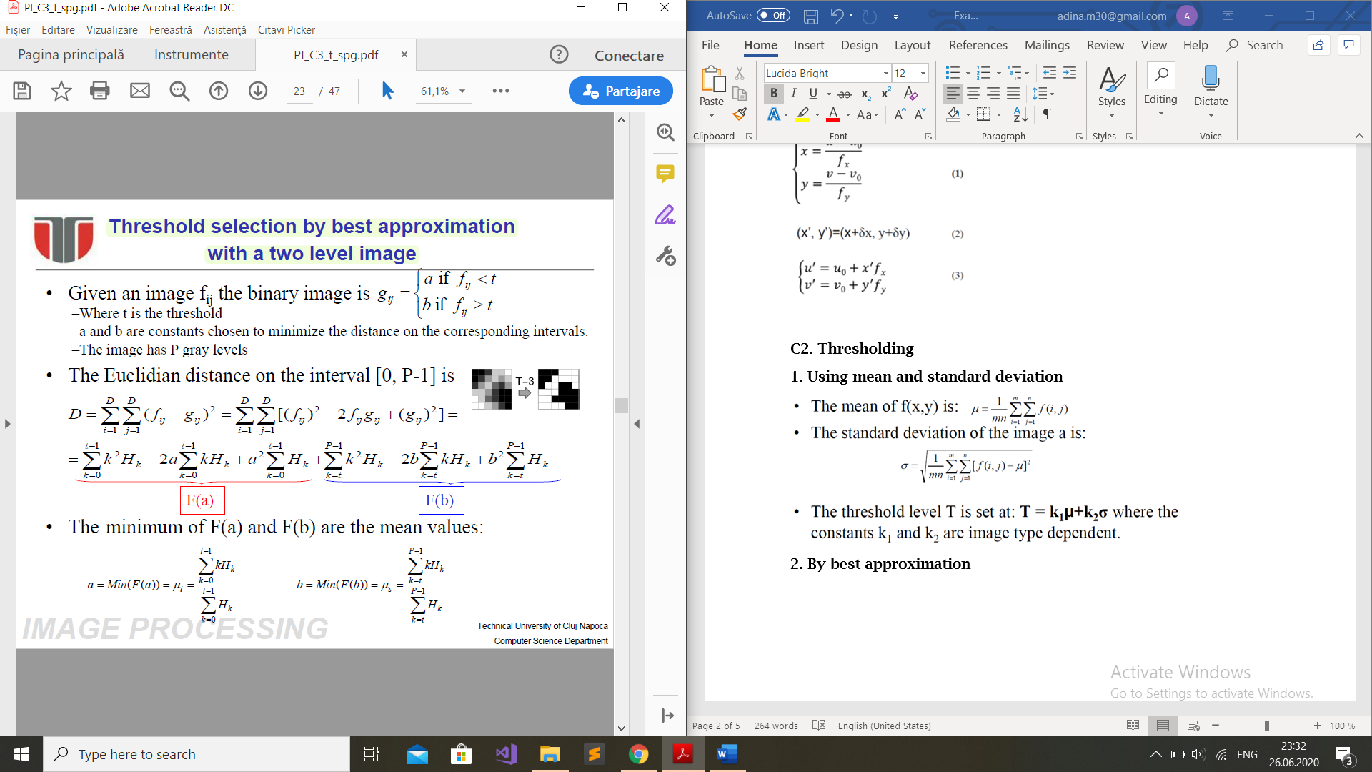

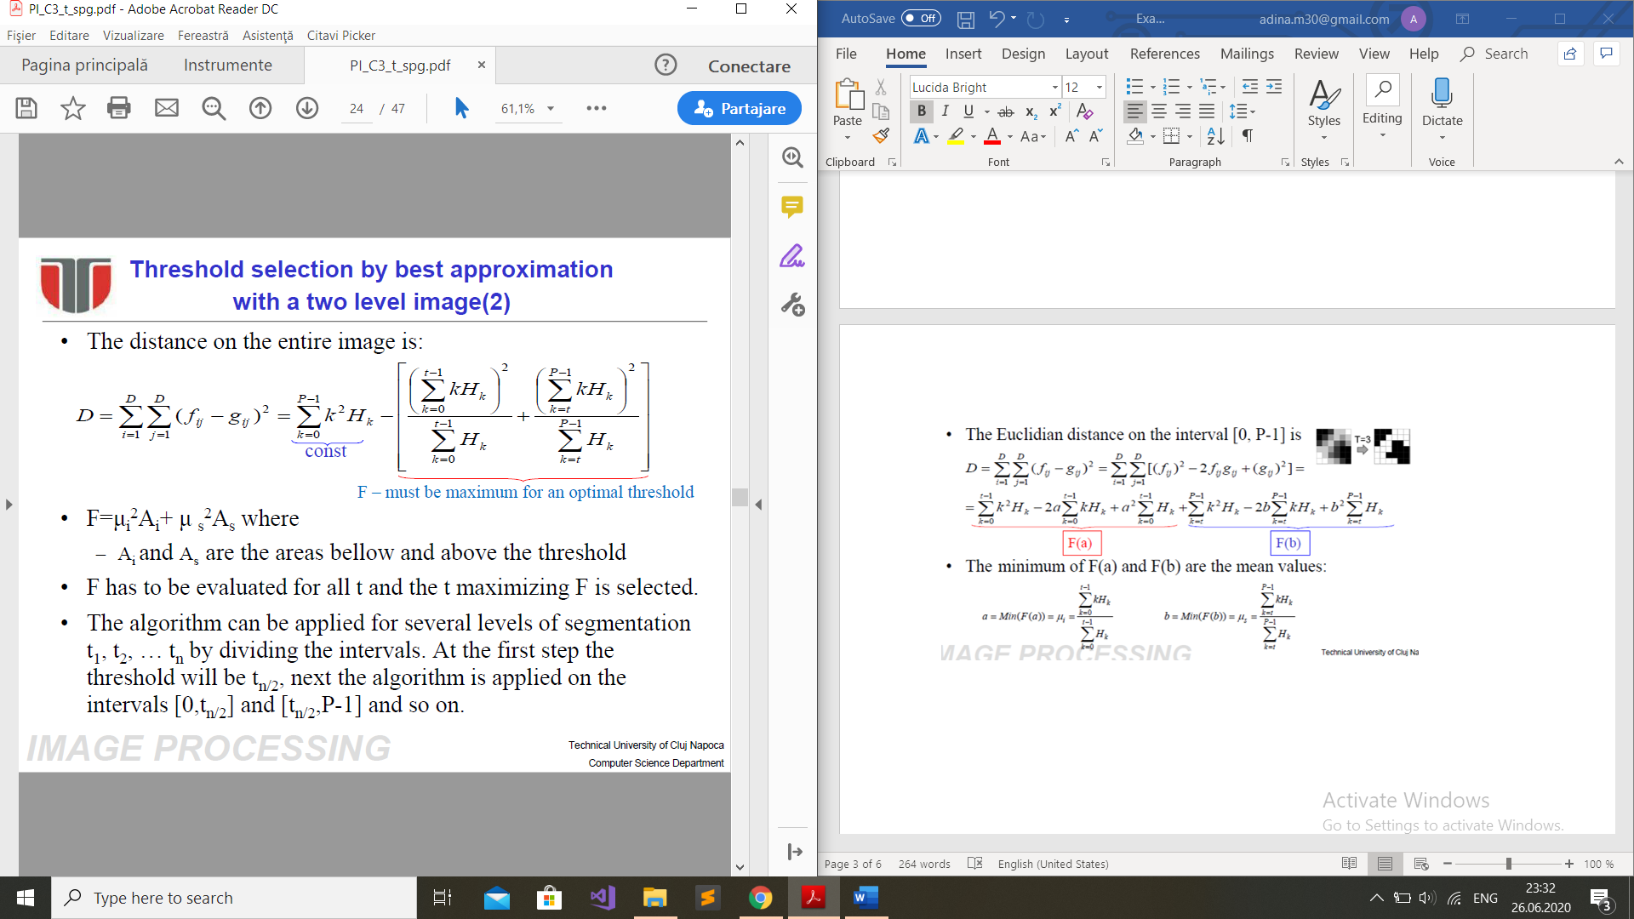

**Geometric properties**

**1. Area**

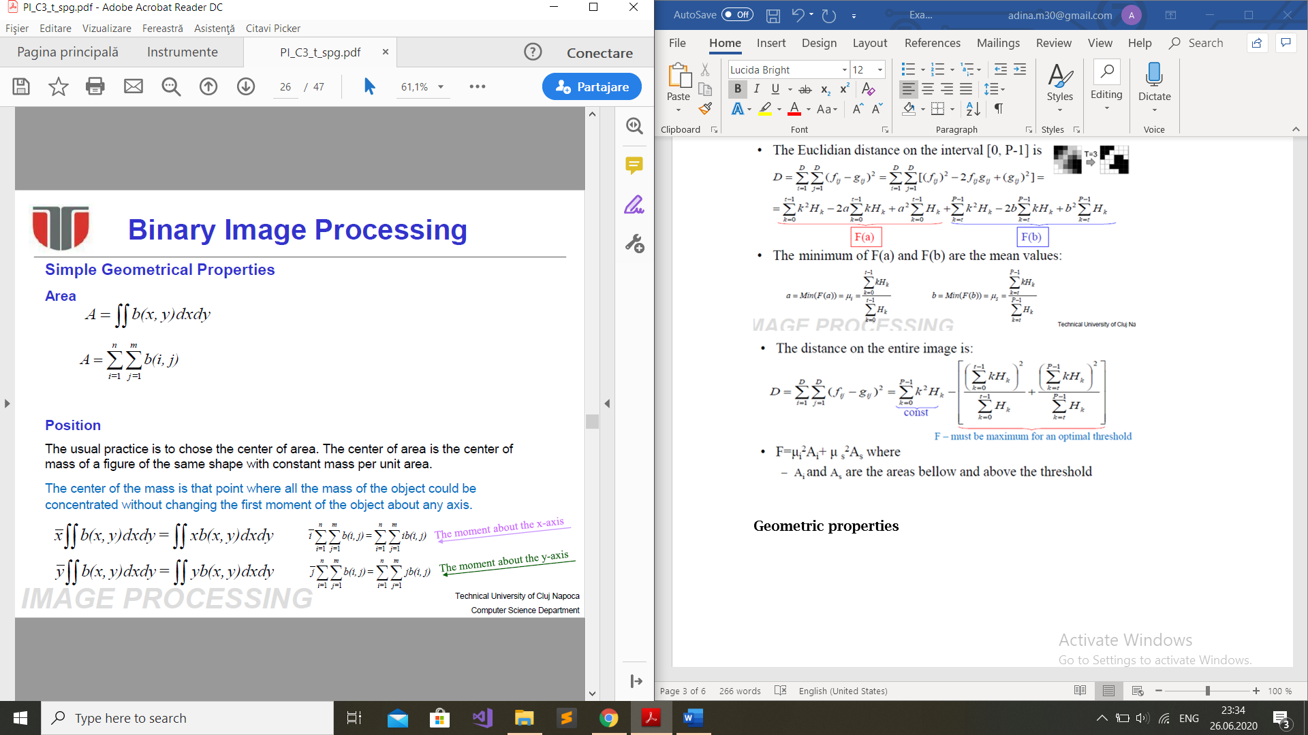

**2. Position**

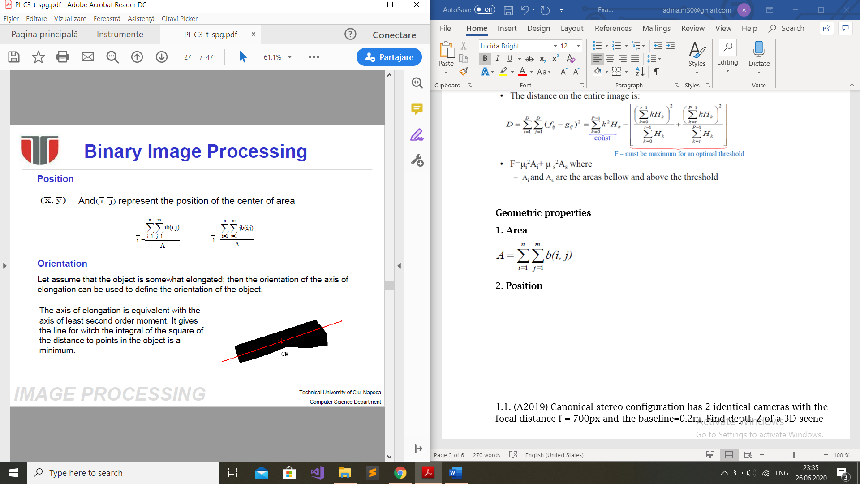

**3. Orientation**  
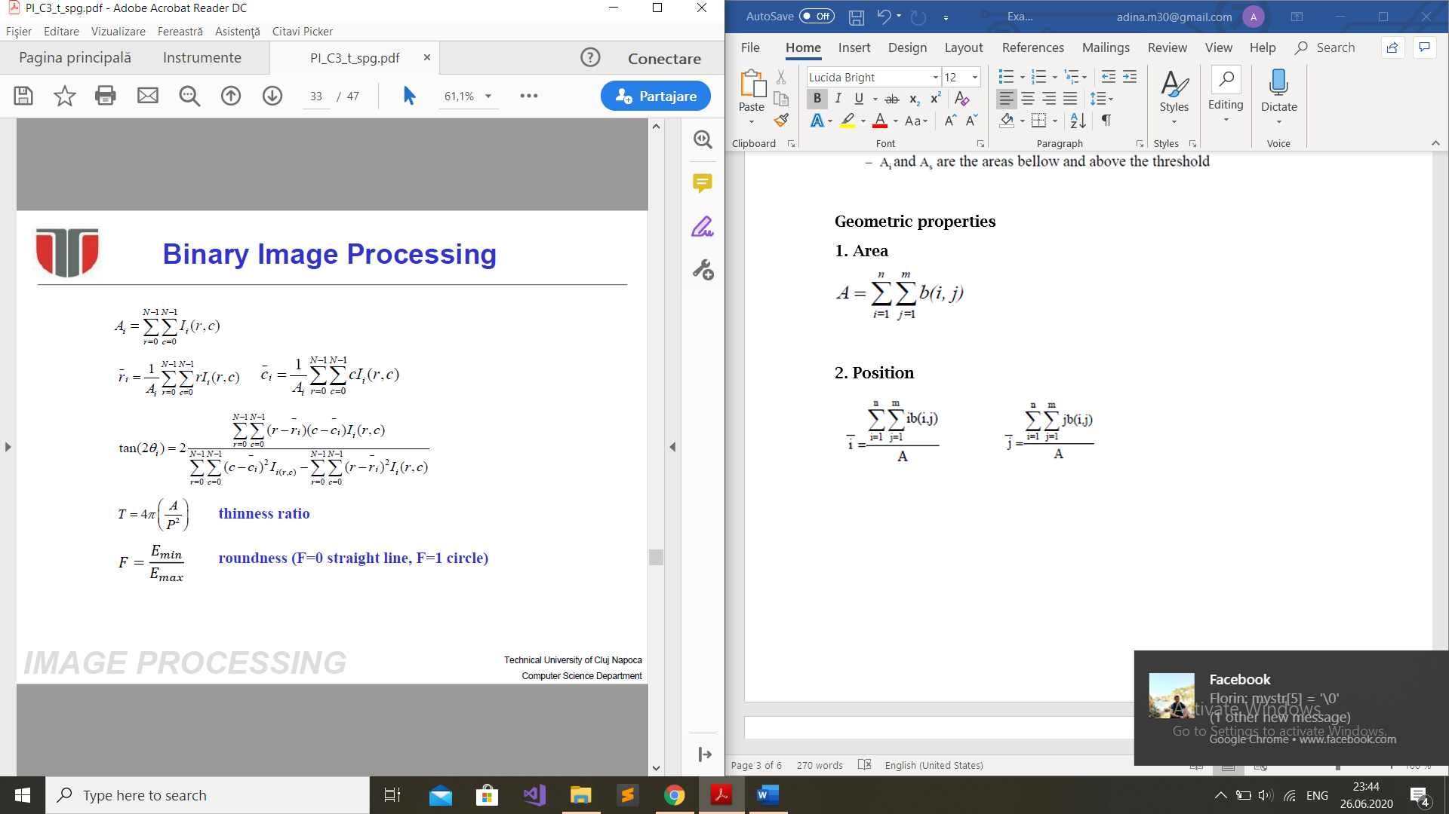

**C4. Contour tracing**

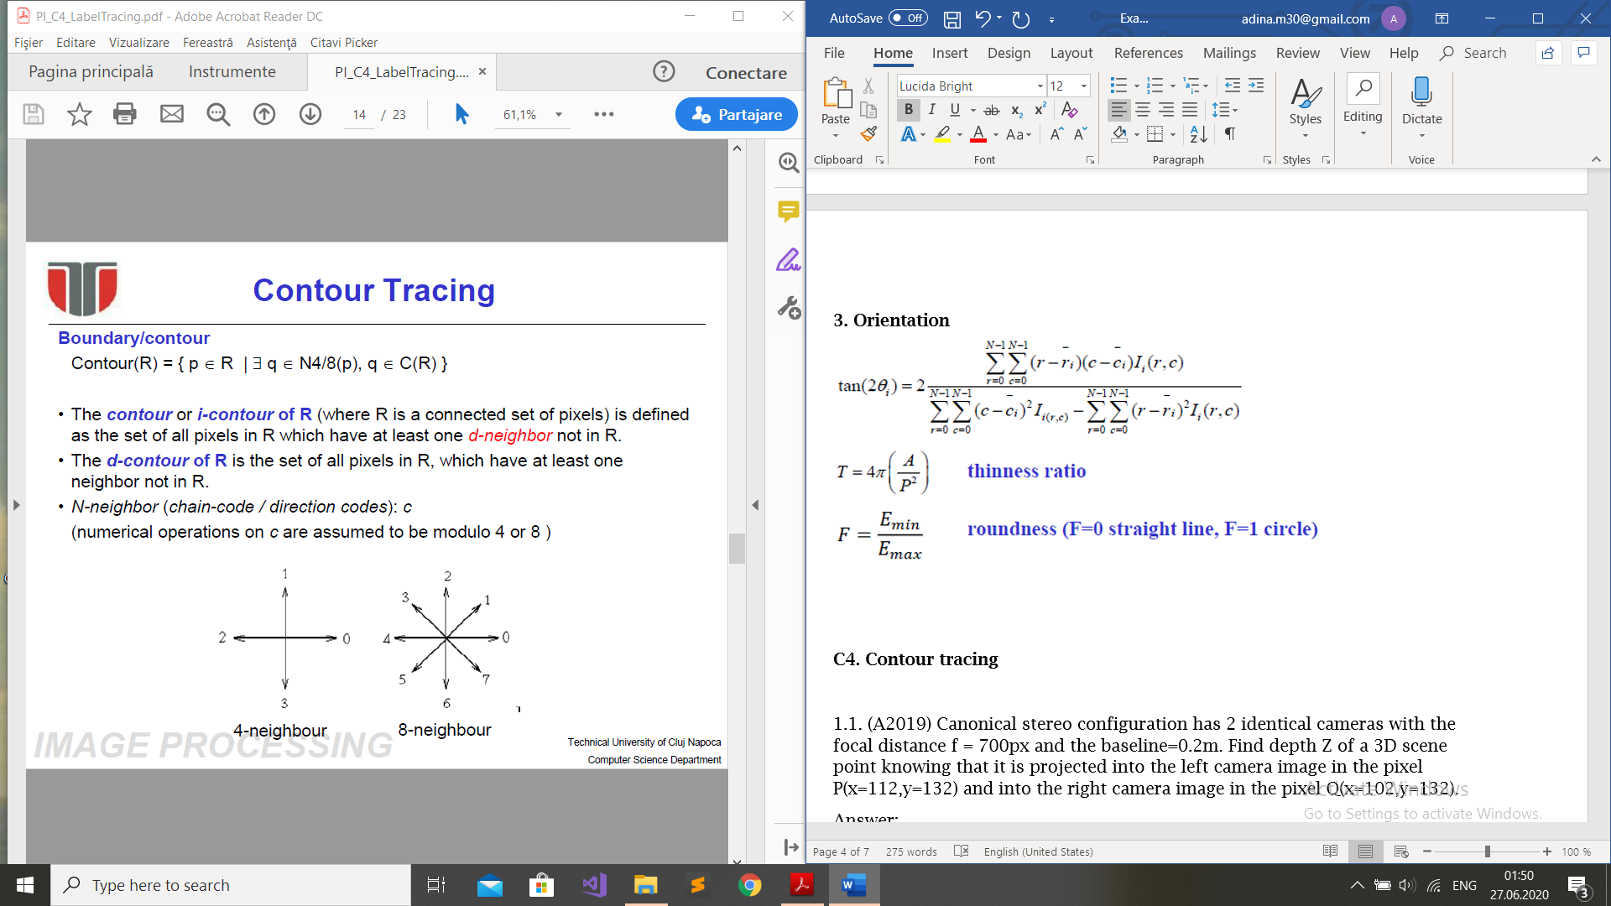

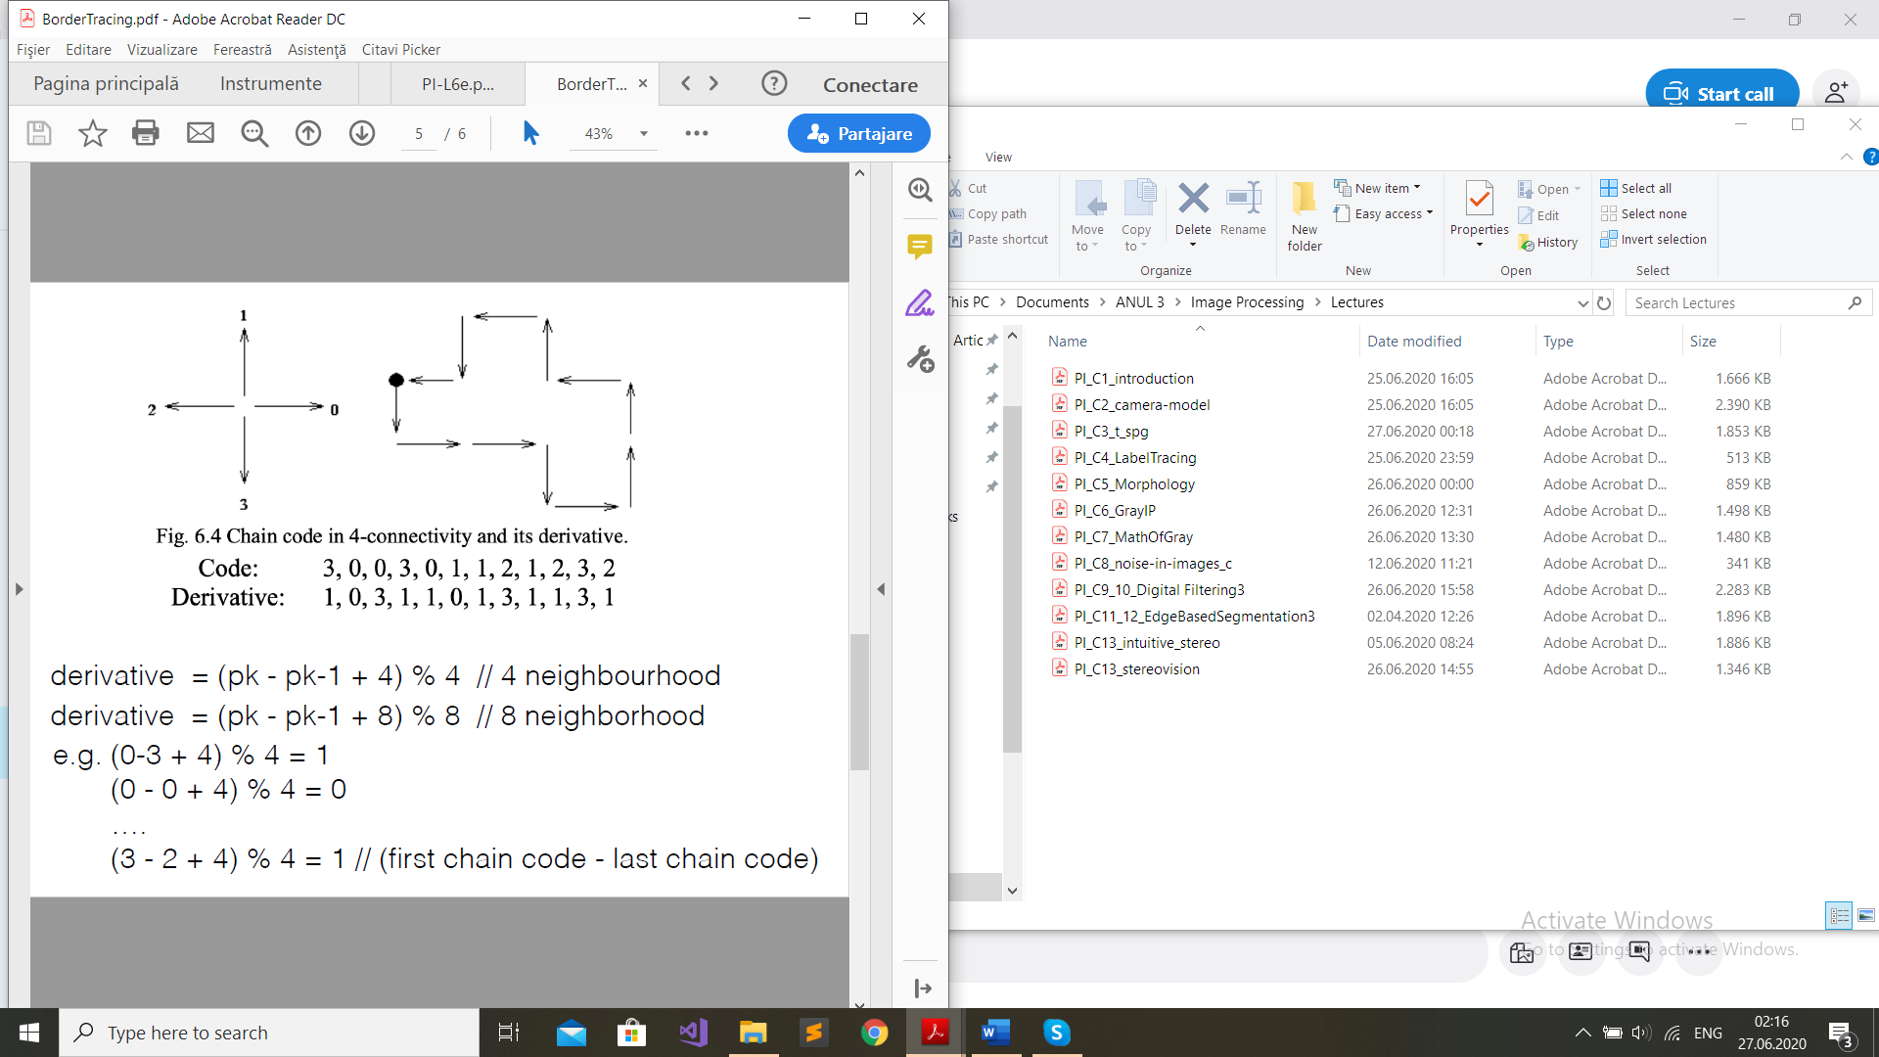

**C5. Morphology**

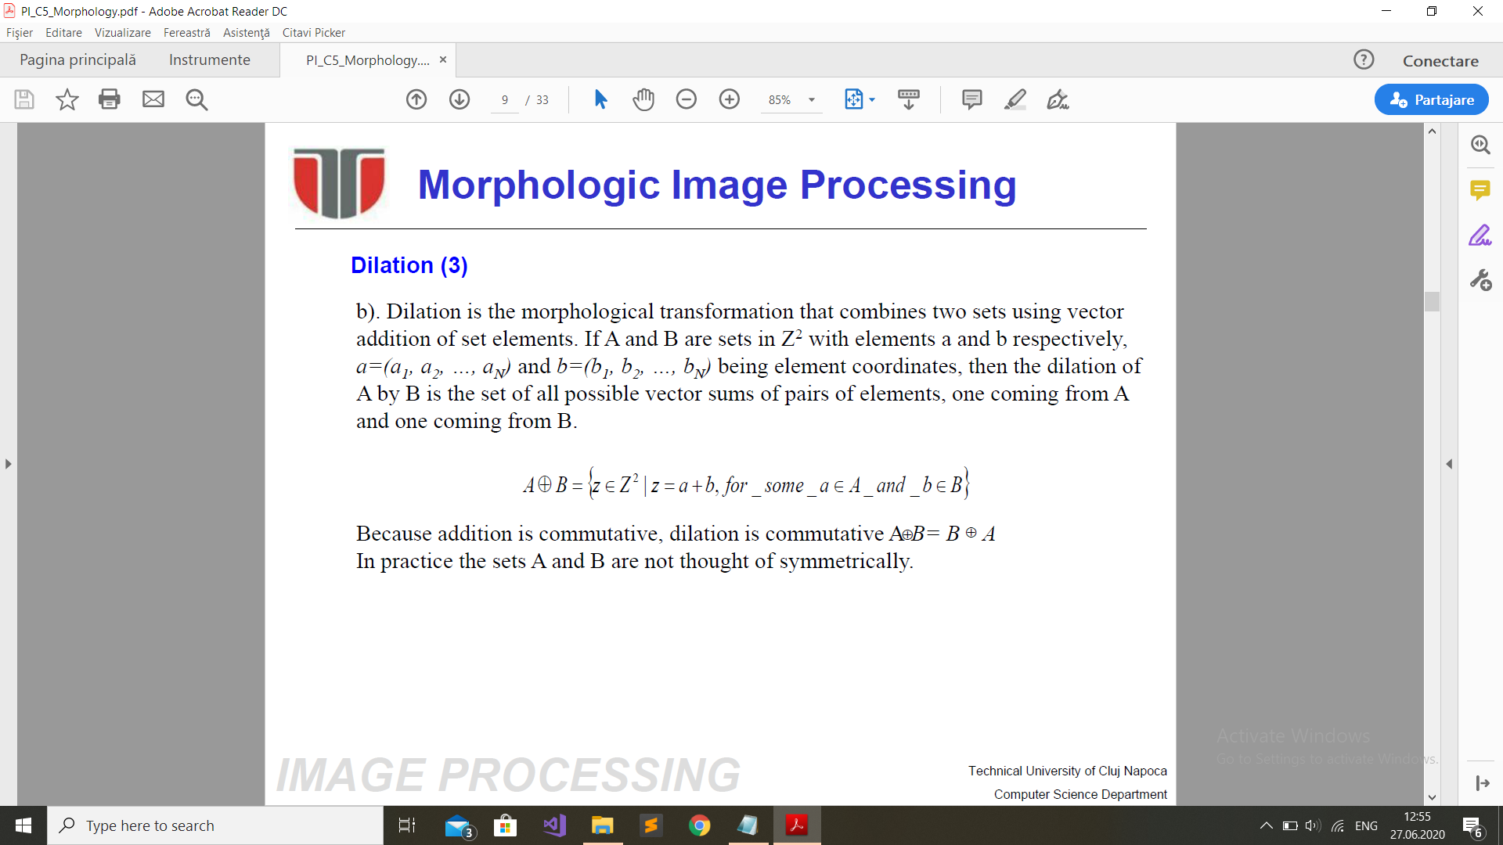

**- used for bridging gaps**

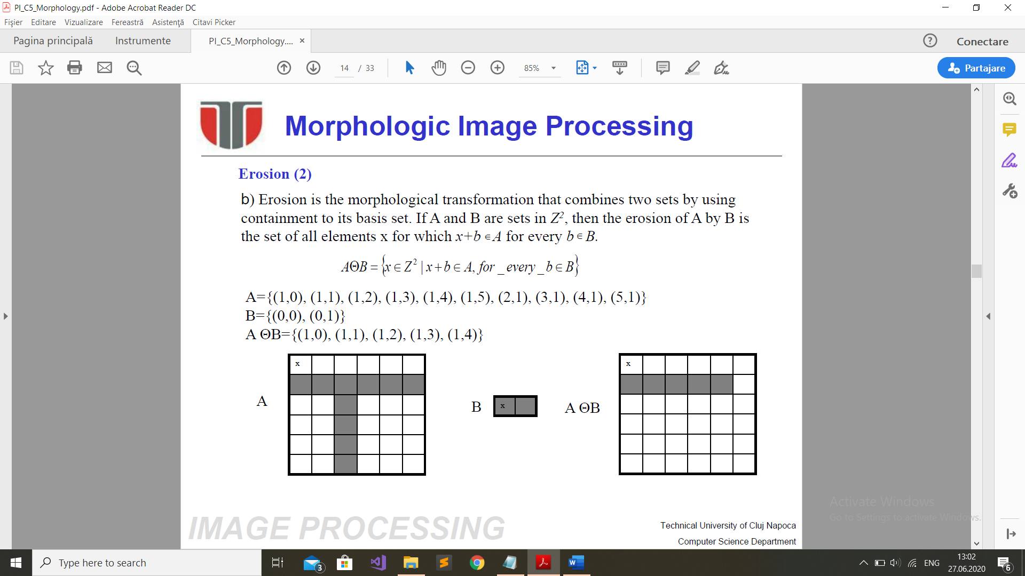

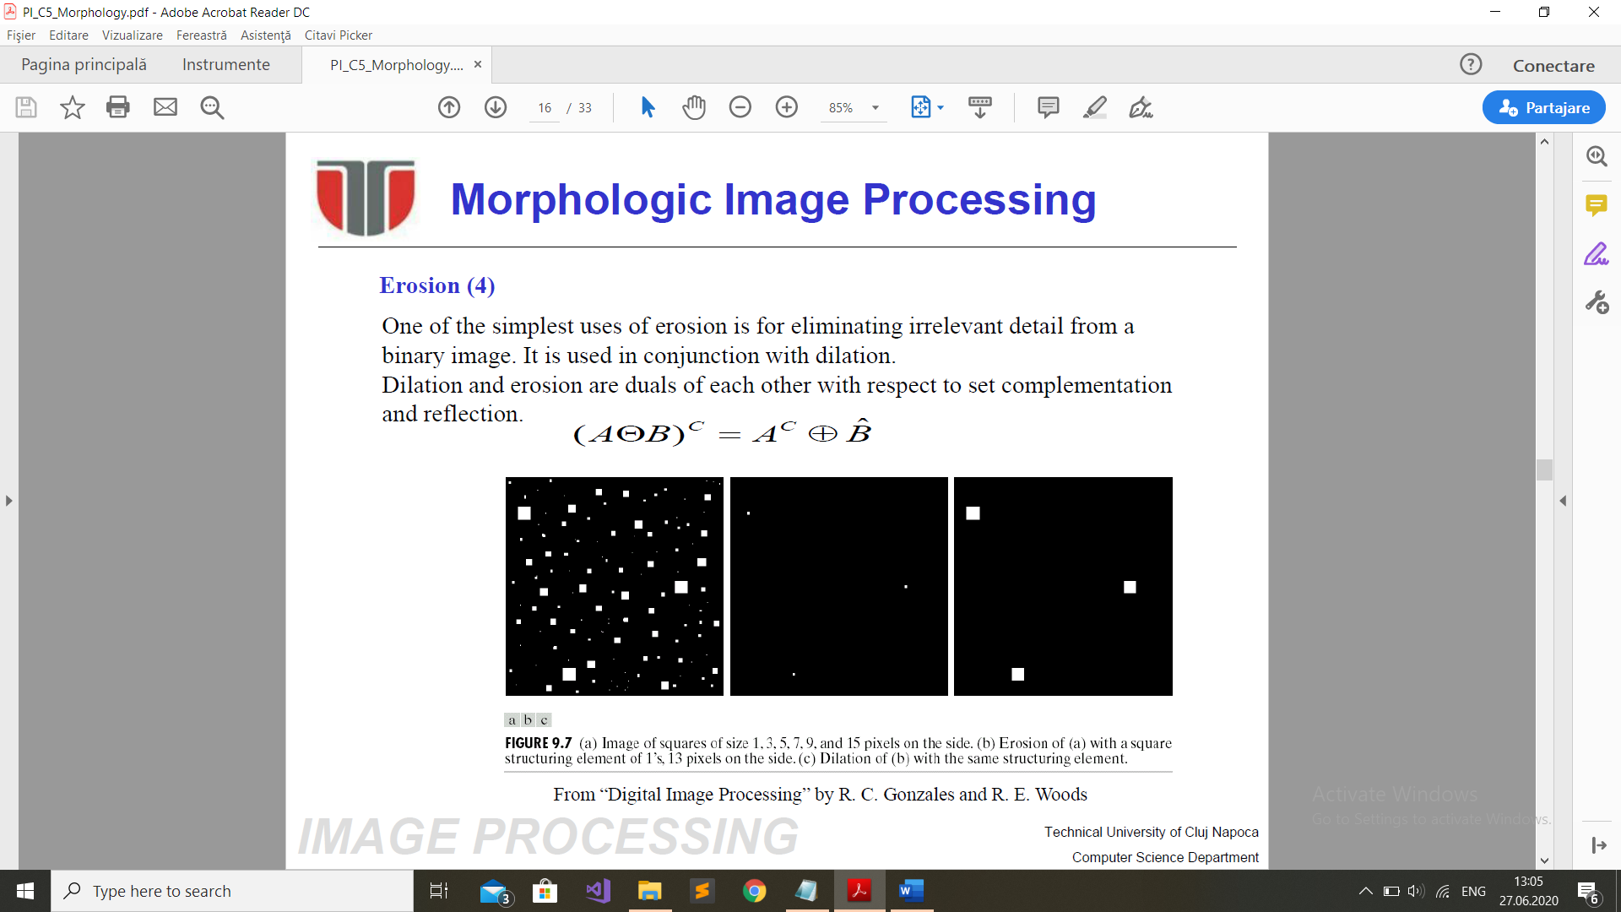

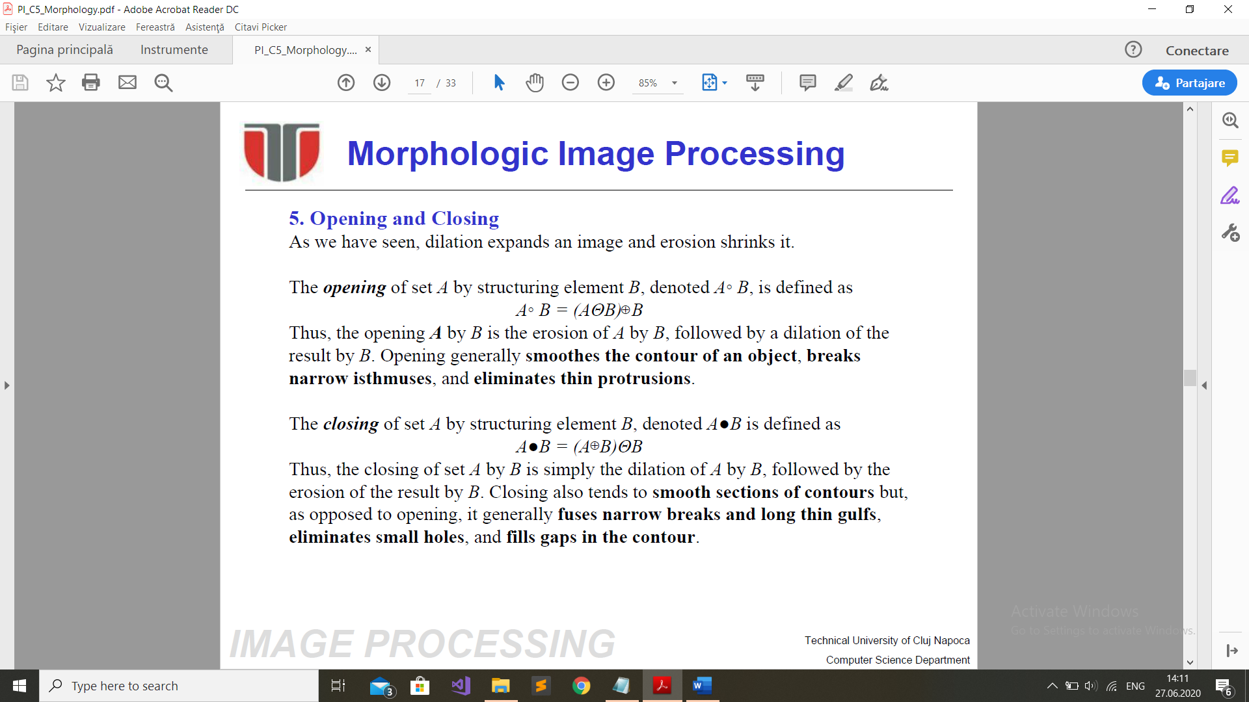

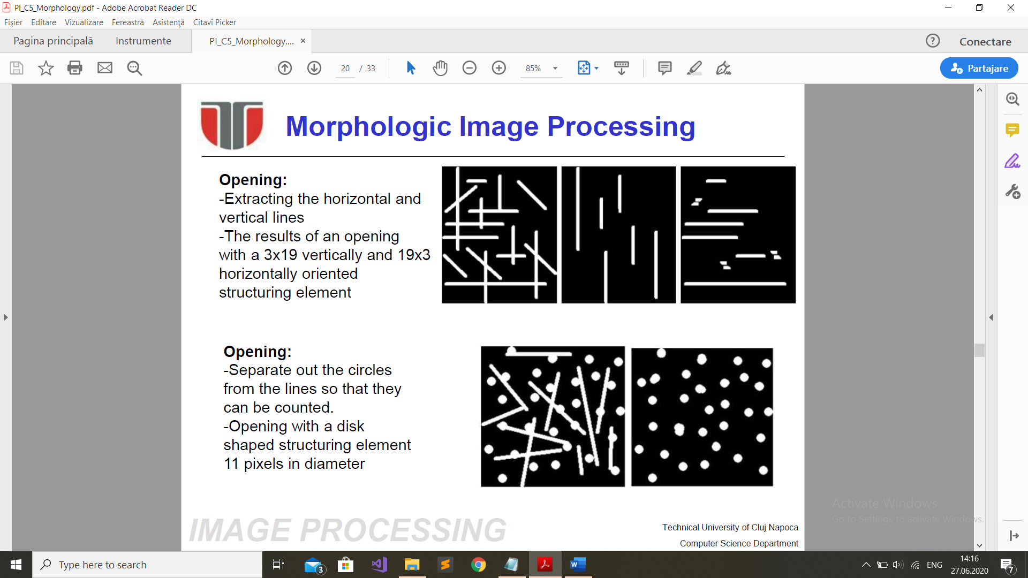

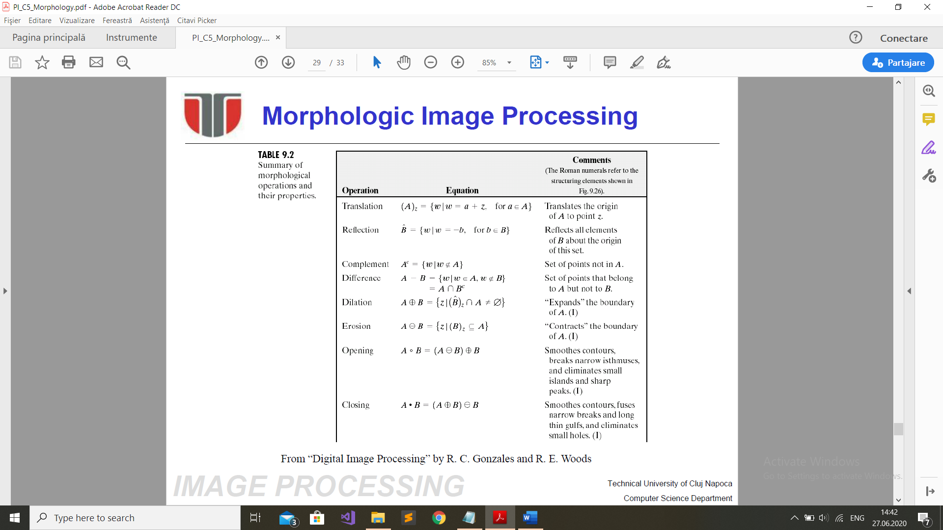

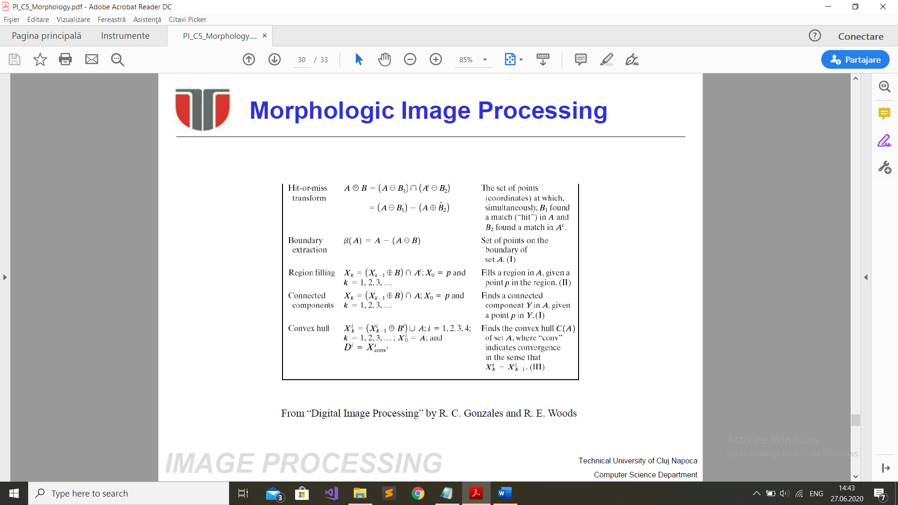

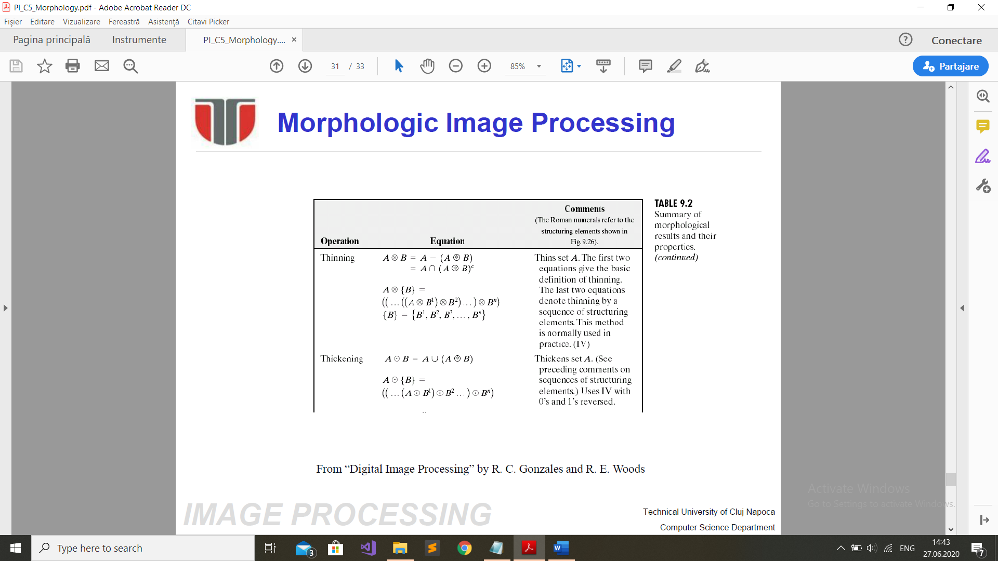

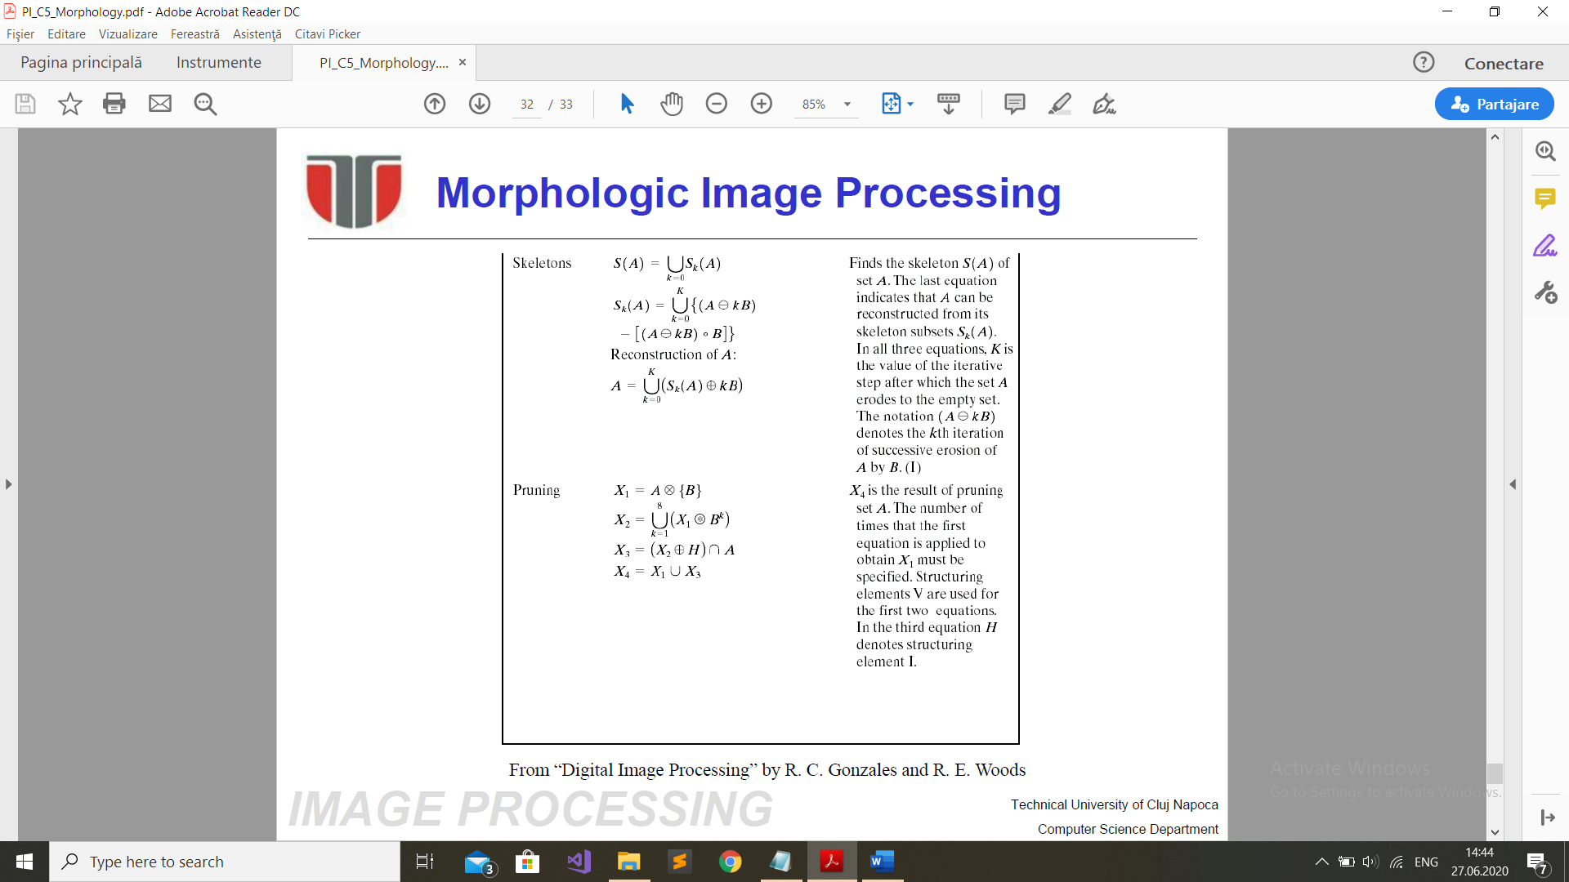

**C6. Statistical properties**

Mean – average brightness  
Deviation - contrast

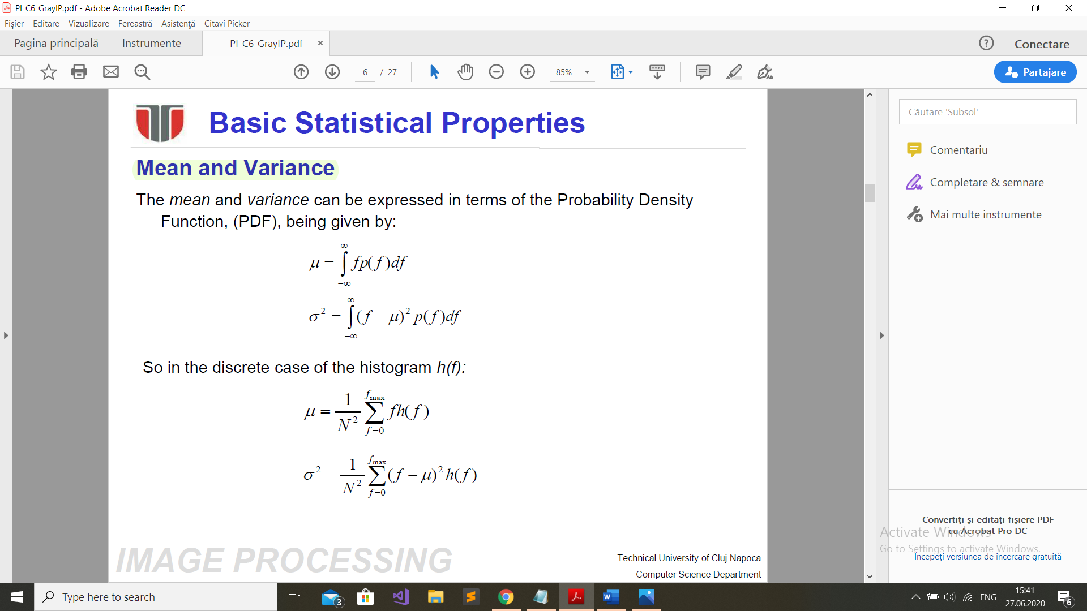

**Basic global thresholding** - bimodal histogram

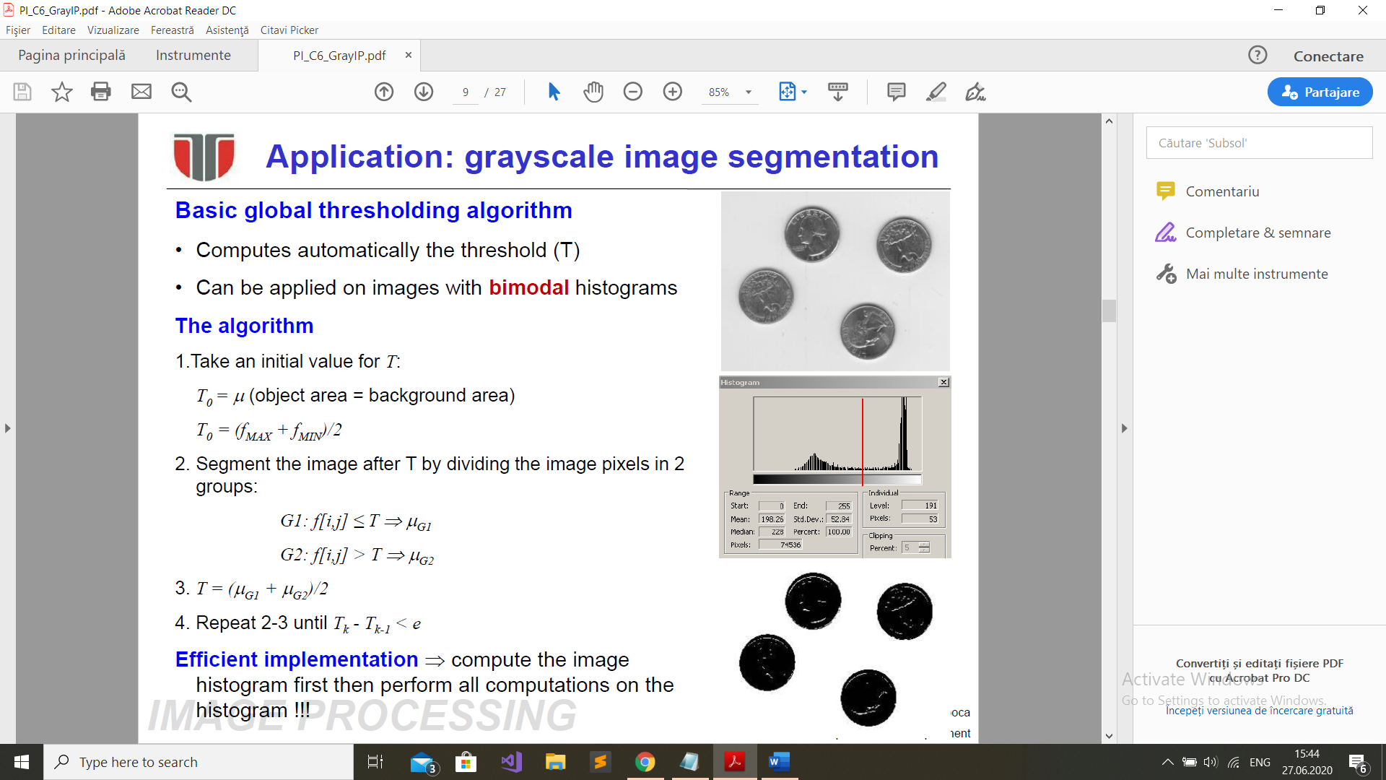

**Histogram stretch / shrink**

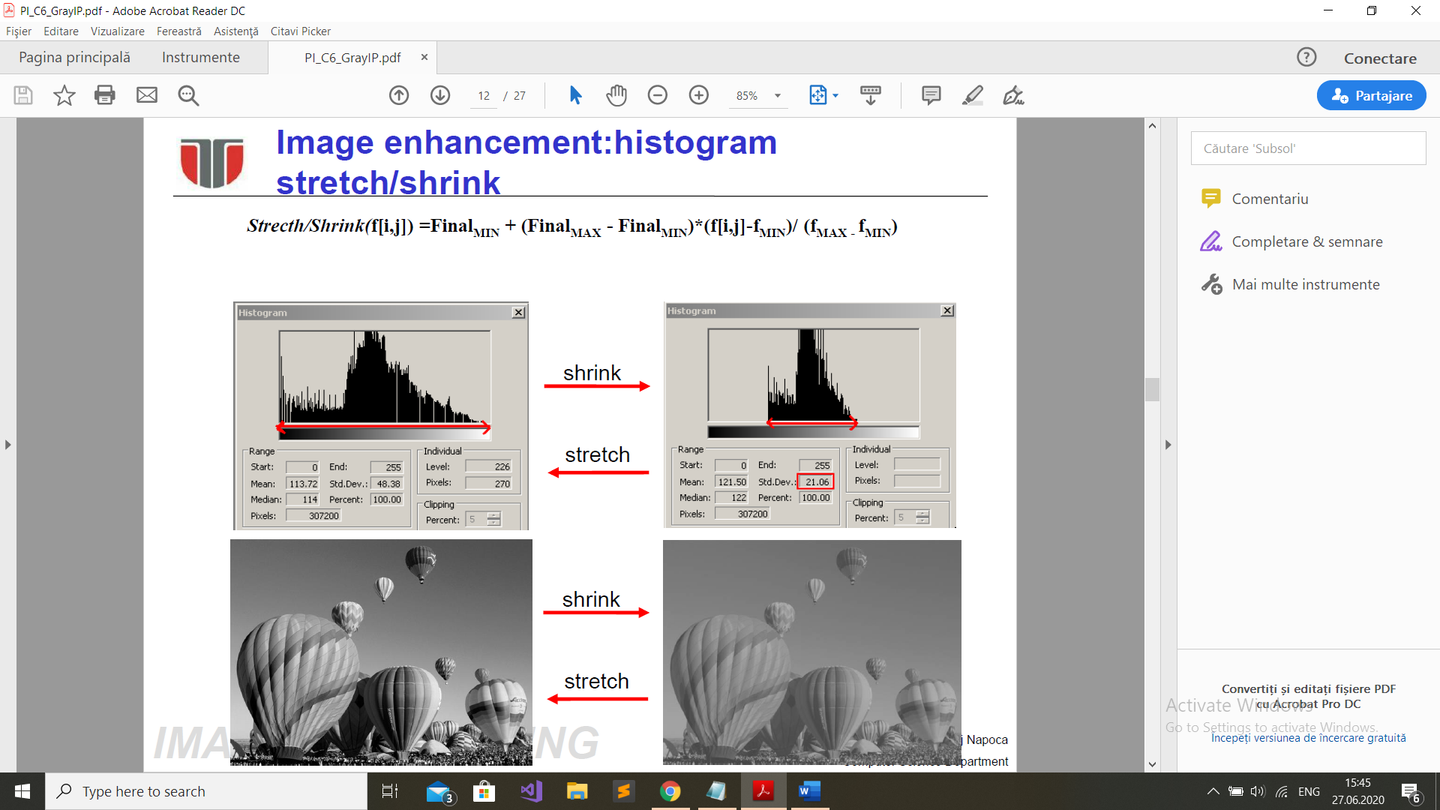

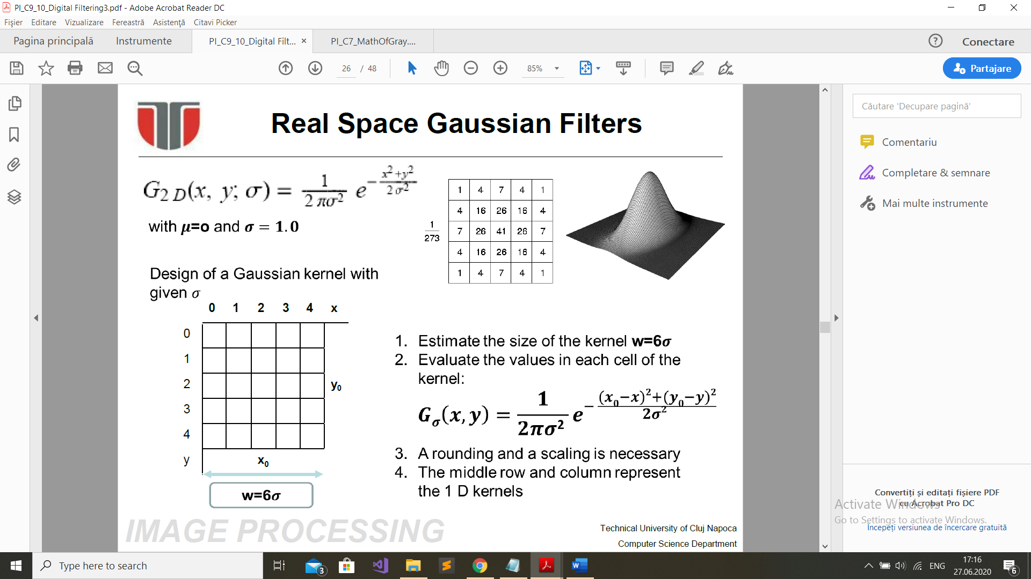

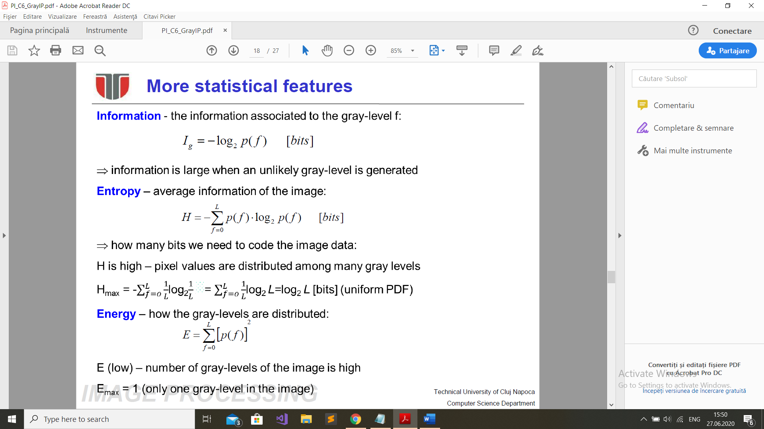

**C8. Noise**

**1. Signal to noise ratio**

  


**C9 C10. Filtering**

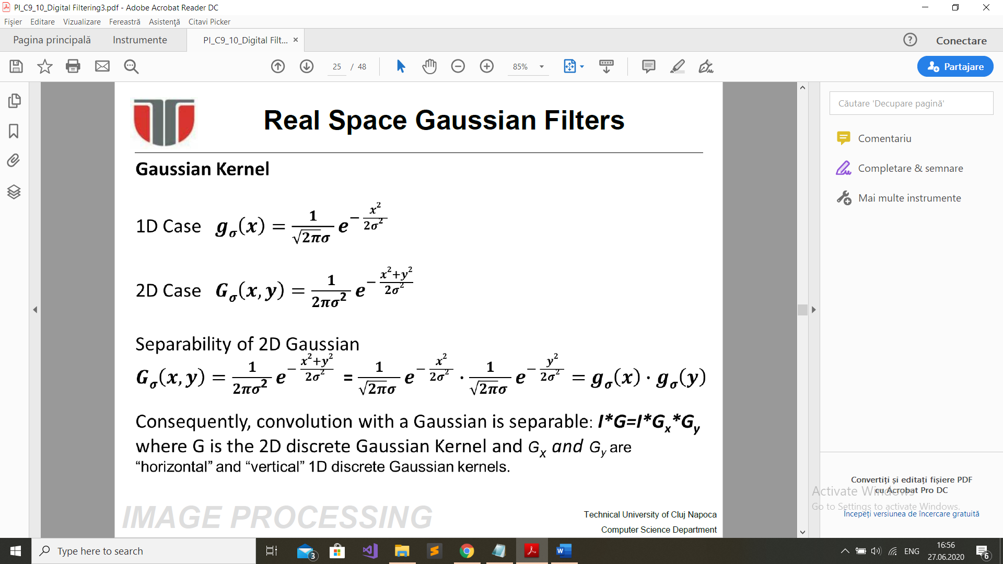

1.1. (A2019) Canonical stereo configuration has 2 identical cameras with the focal distance f = 700px and the baseline=0.2m. Find depth Z of a 3D scene point knowing that it is projected into the left camera image in the pixel P(x=112,y=132) and into the right camera image in the pixel Q(x=102,y=132).

Answer:

f = 700px  
b = 0.2m  
P(x=112, y=132) (left)  
Q(x=102, y=132) (right)

**Z = (f*b)/d** = (700*0.2)/10 = 7*2 = 14  
**d = xL – xR** = xP – Qx = 112 – 102 = 110

1.2 (B2019) f=600px, z = 15m, P(x=1120, y=314), Q(x=1108, y=314)  
b = (Z*d)/f = 15*(1120-1108)/600px = 15*12/600 = 0.3

2.1. Threshold selection by best approximation with a two level image.  
2.2. Basic global thresholding algorithm (based on statistical features).

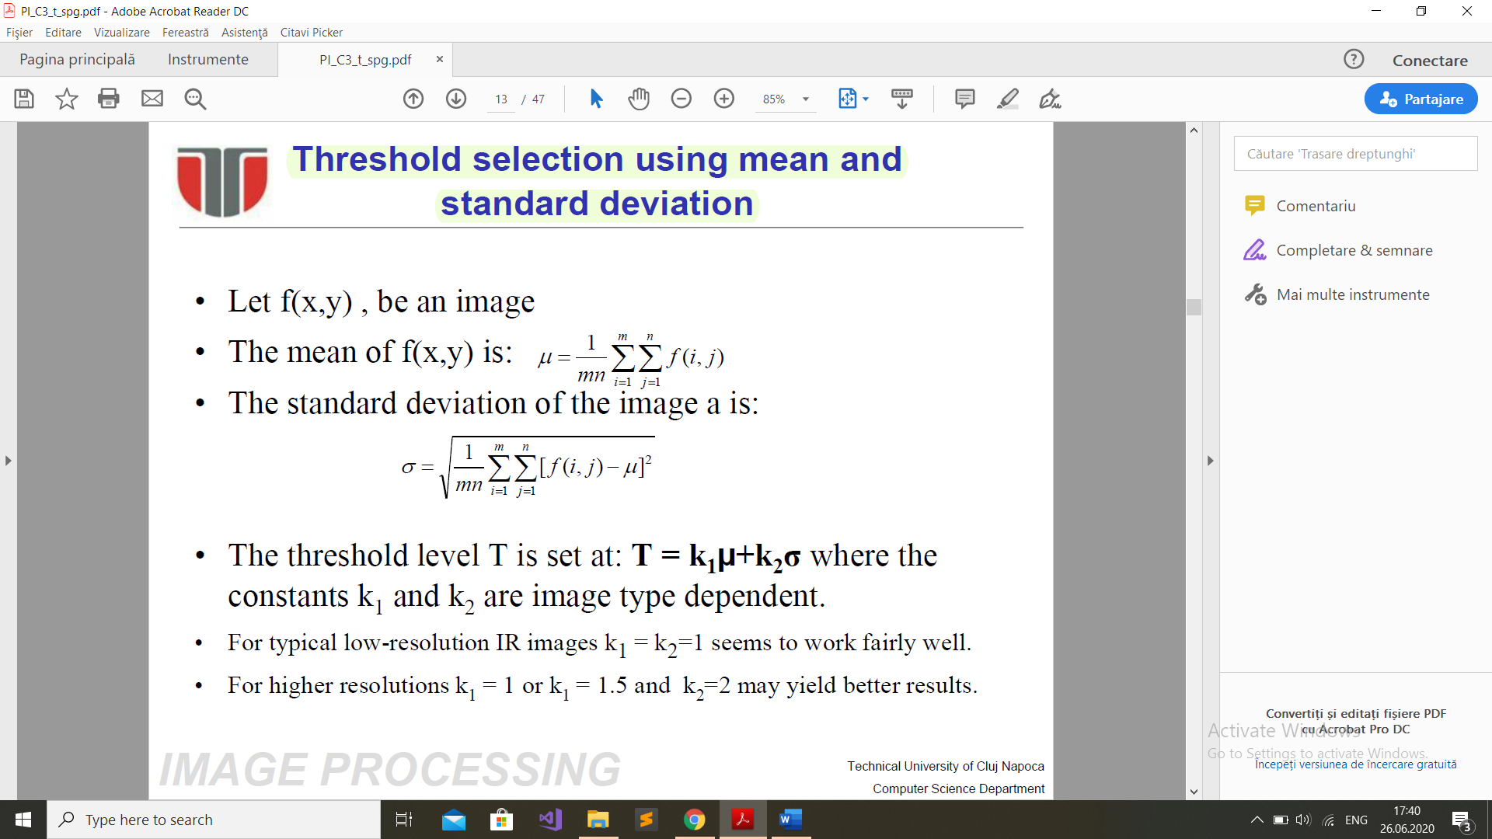

Meeting hints

* Aplicare de algoritmi
* Din camera plane in image plane – ecuatia de proiectie, pg 19
* Distorsiunile lentilelor
* World->camera transformation, parametrii intrinsic,extrinsic
* 3d world -> 2d image mapping
* Bayer pattern
* Dimensiune pixel
* Daca distanta focala e data in metric => exprimare in pixeli
* Chain codes
* Signal to noise ratio